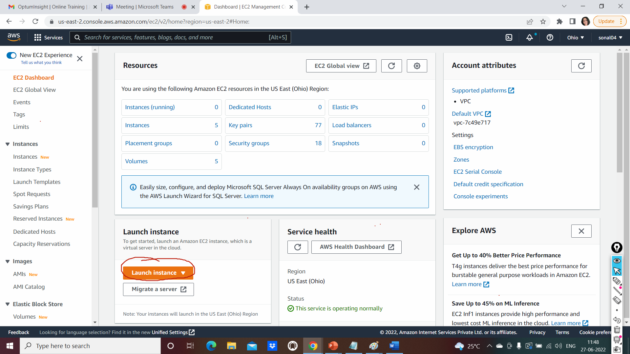

Click on launch Instance

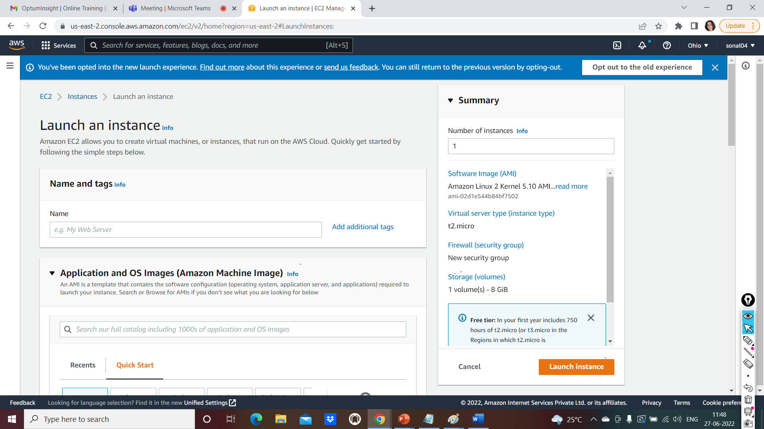

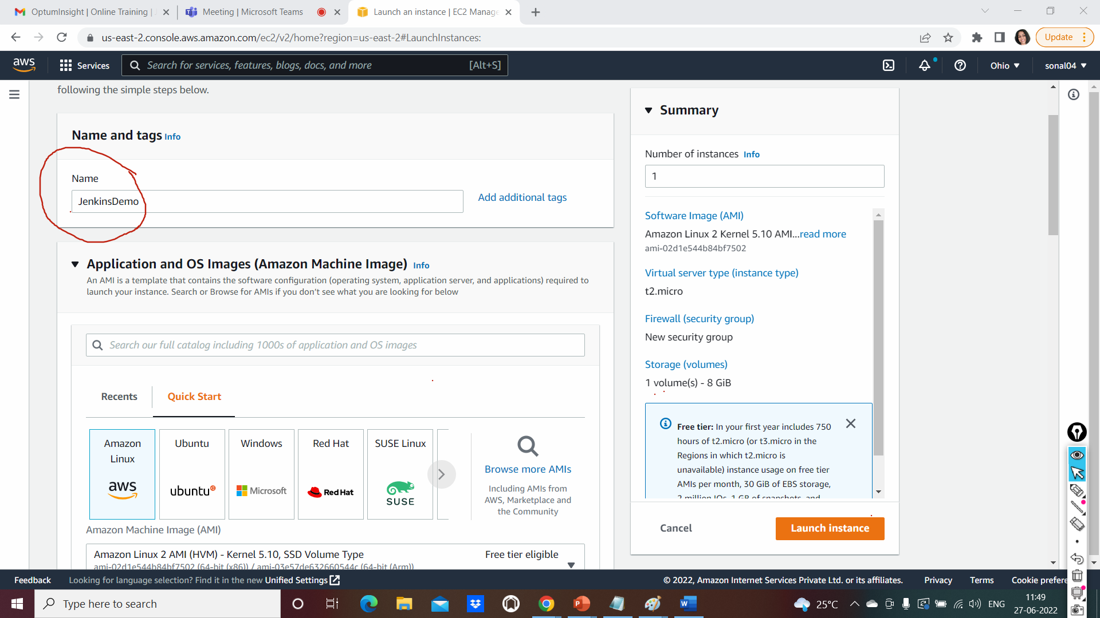

Select the Amazon Machine Image

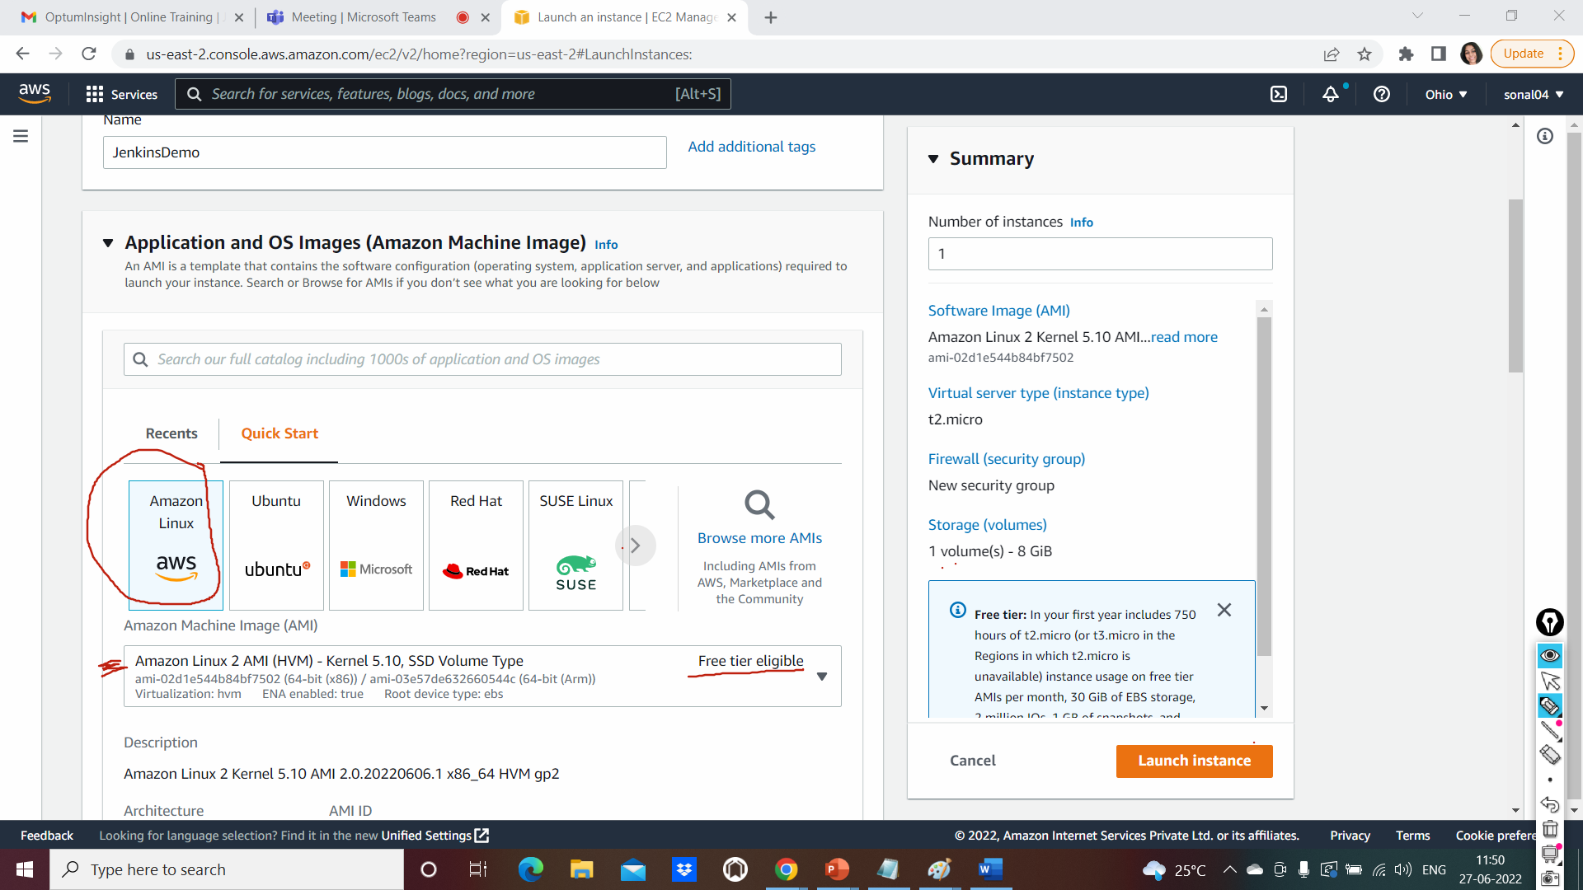

Default t2 micro select as Instance type

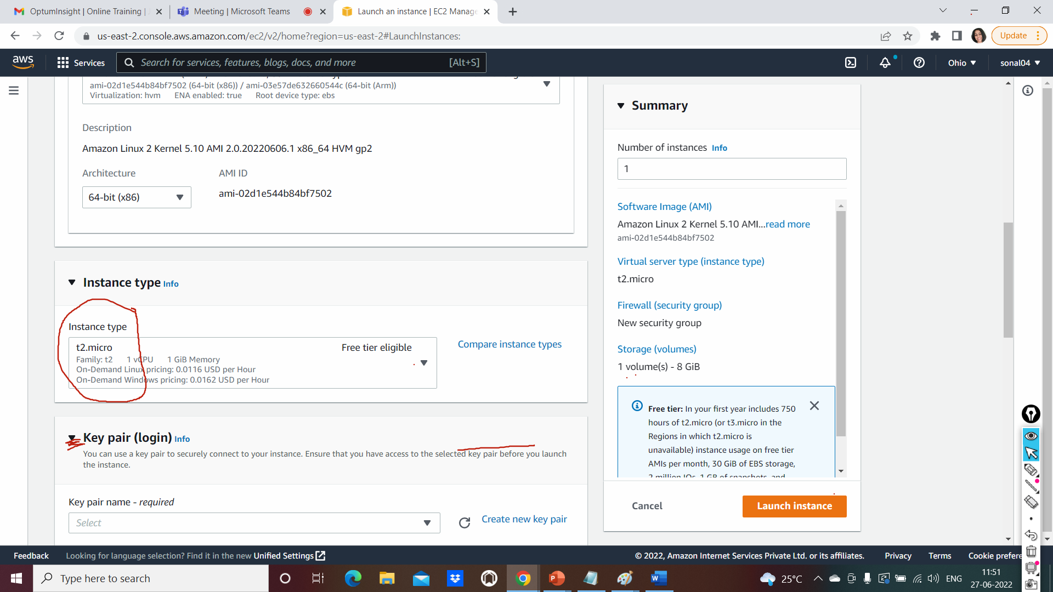

Create a new key pair. Download the key pain in your downloads

Don’t change the location of the file. Let it be in downloads folder

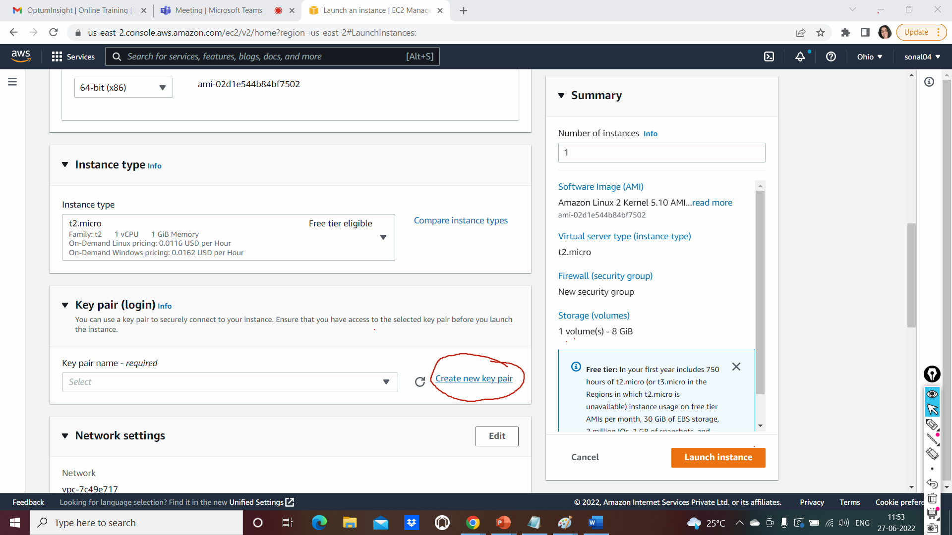

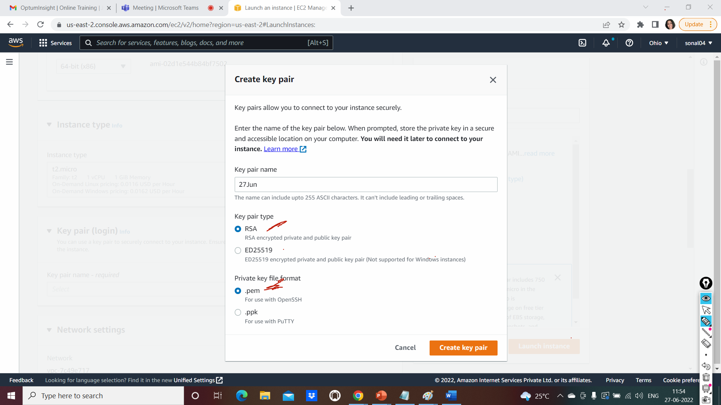

Set up the firewall rule or security group

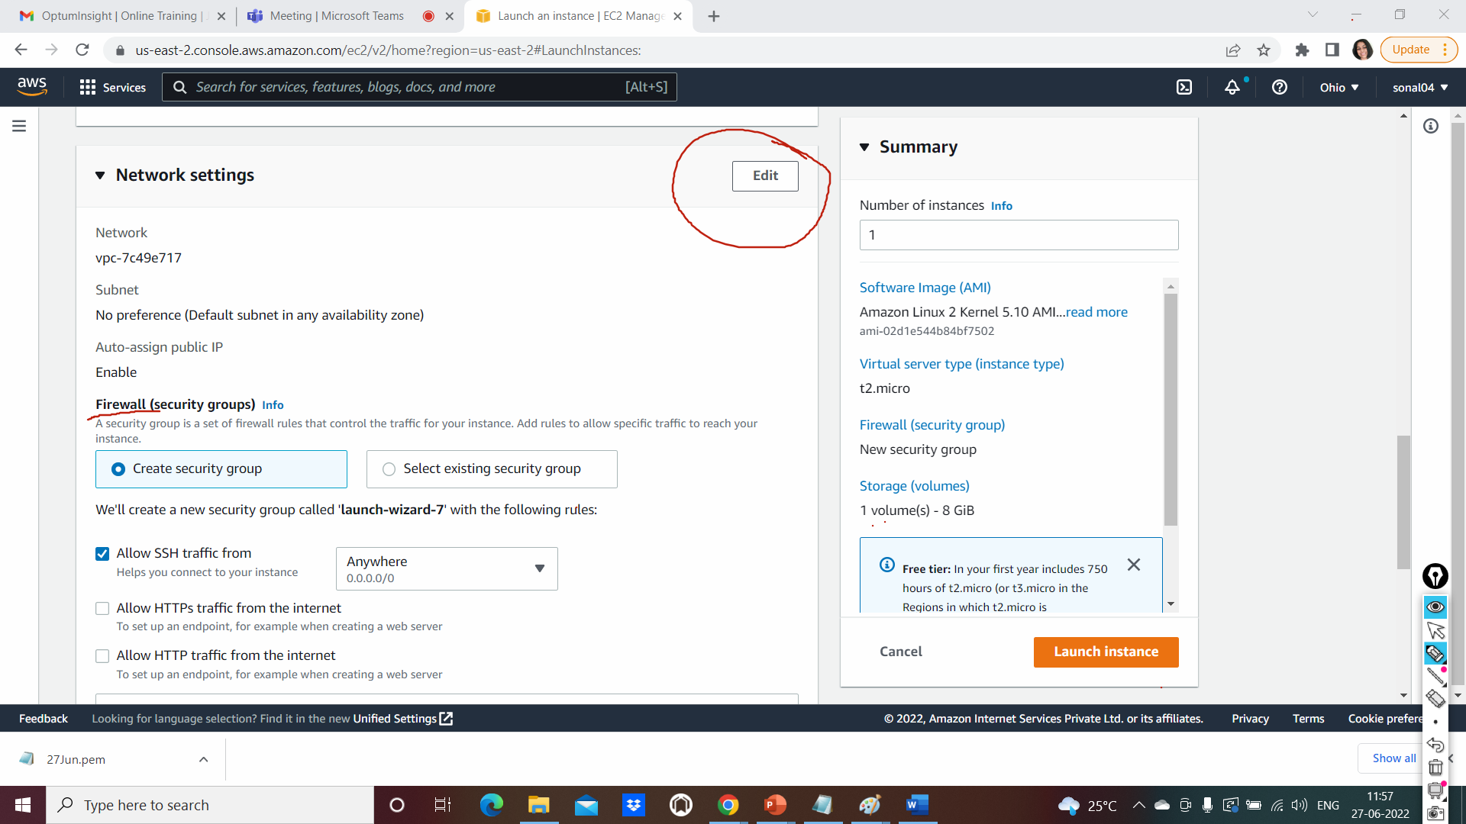

Scroll down and click add security group rule

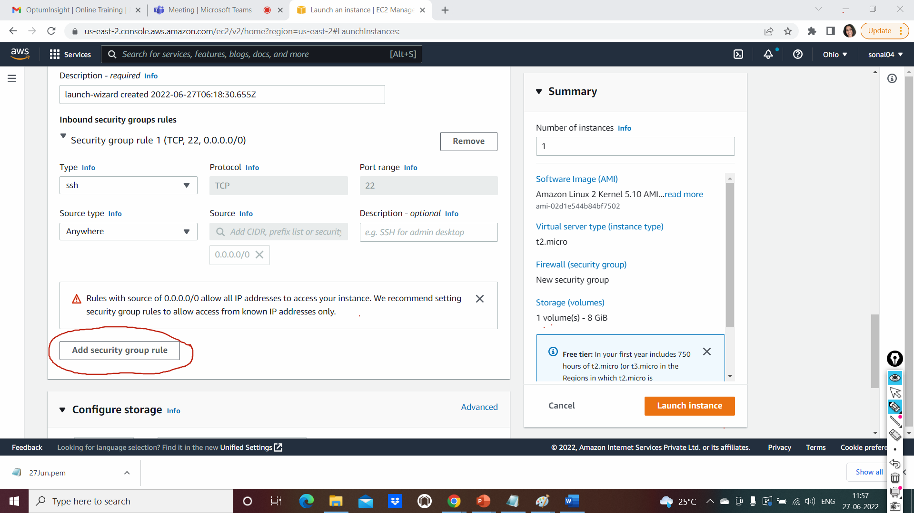

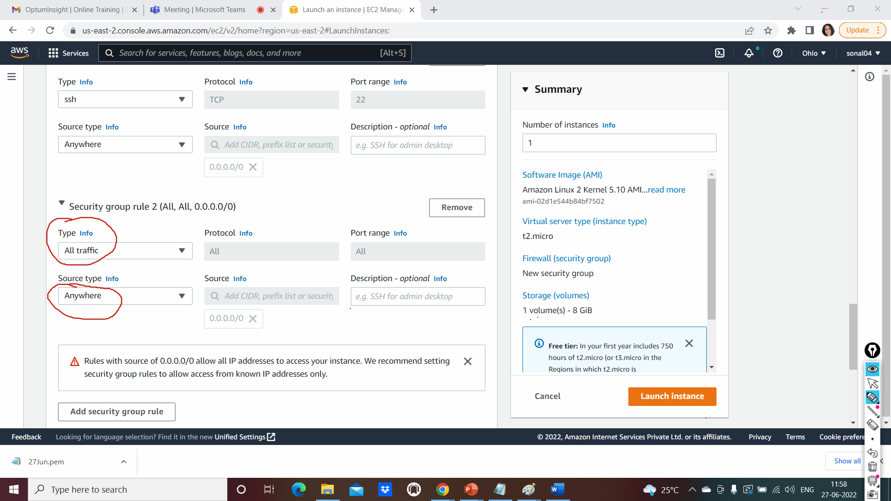

Click on launch instance and it will create the instance

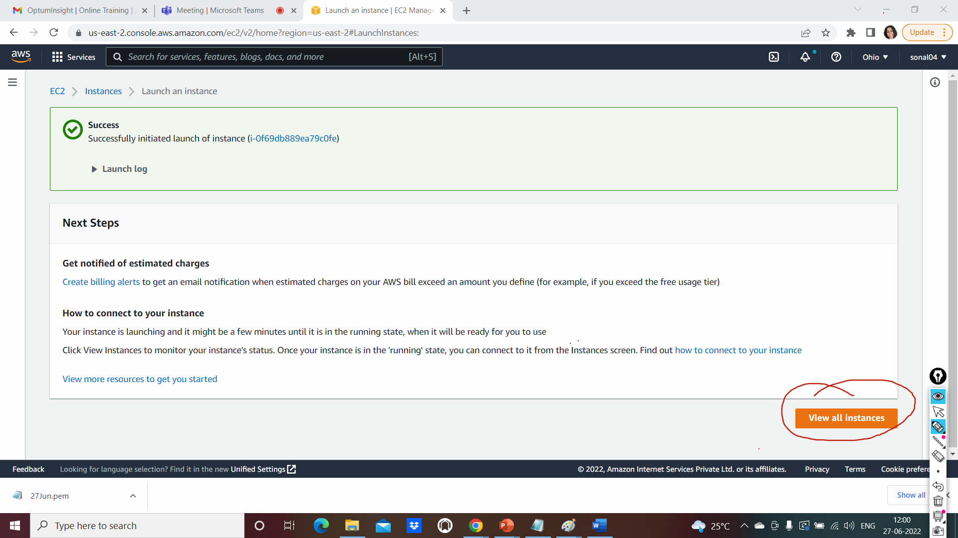

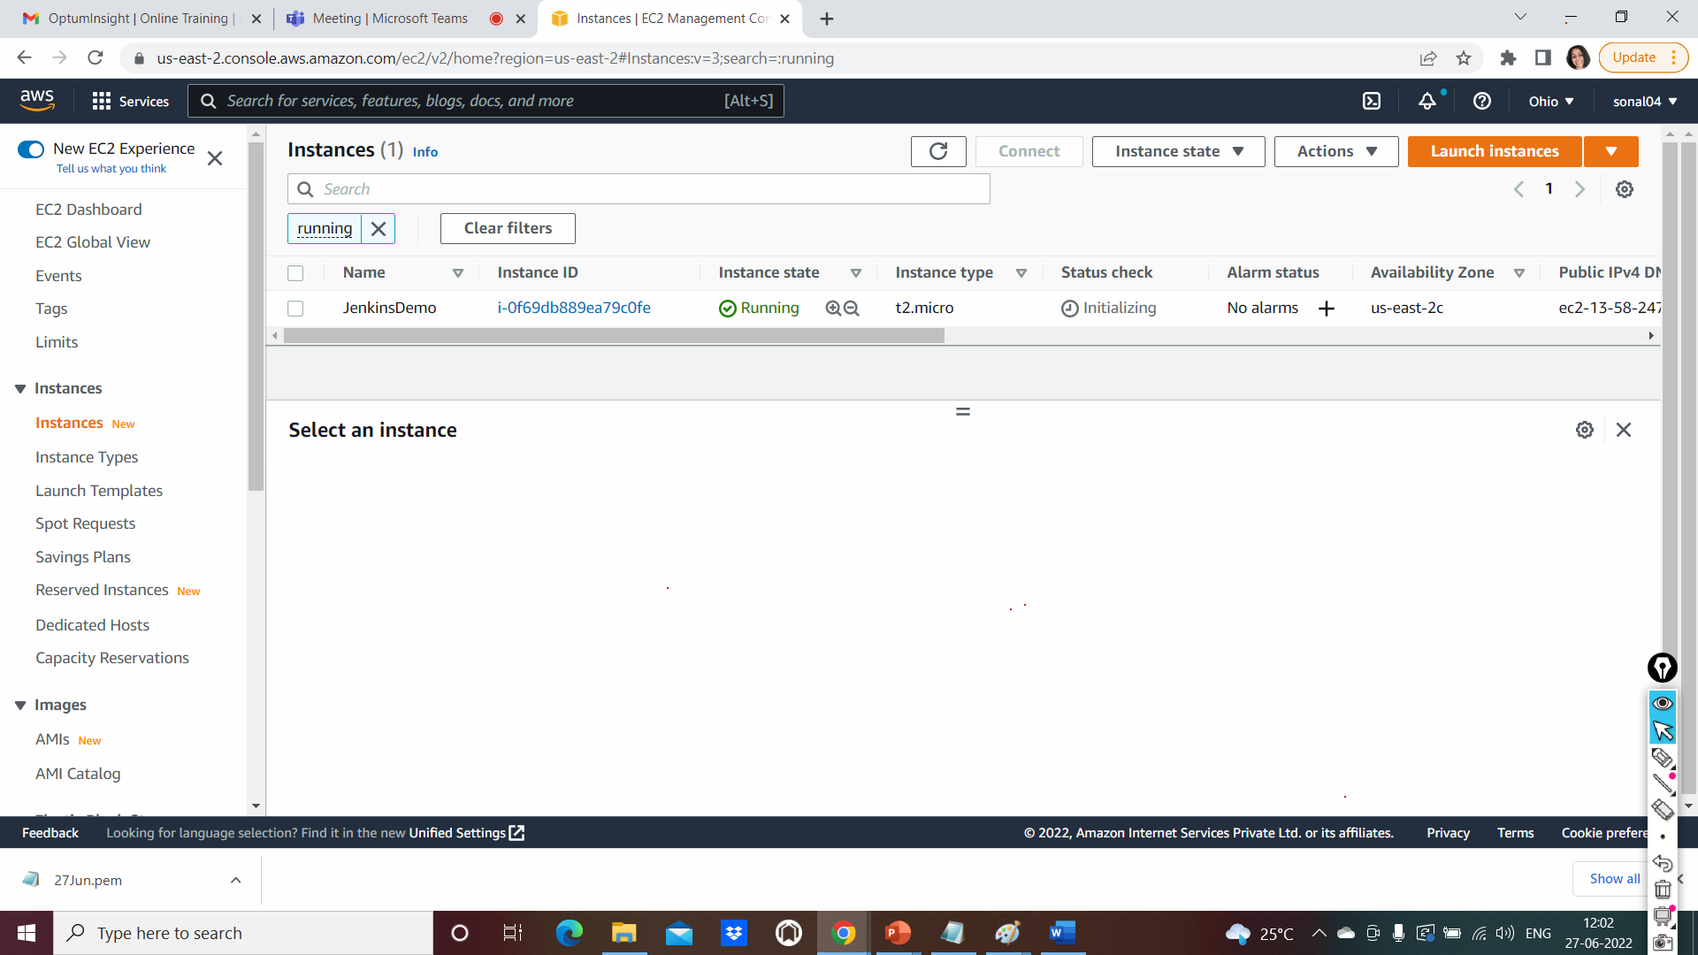

How to connect to the instance

SSH to connect to AWS server using SSH clinet

Use browser to connect to AWS

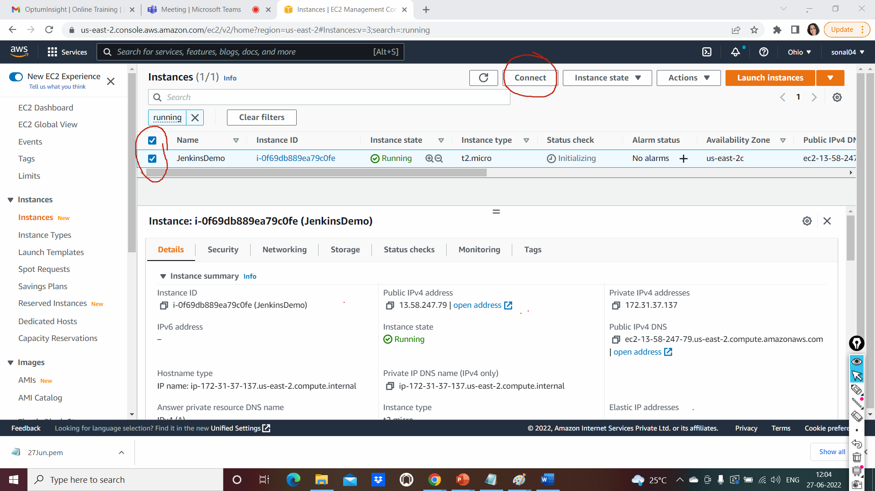

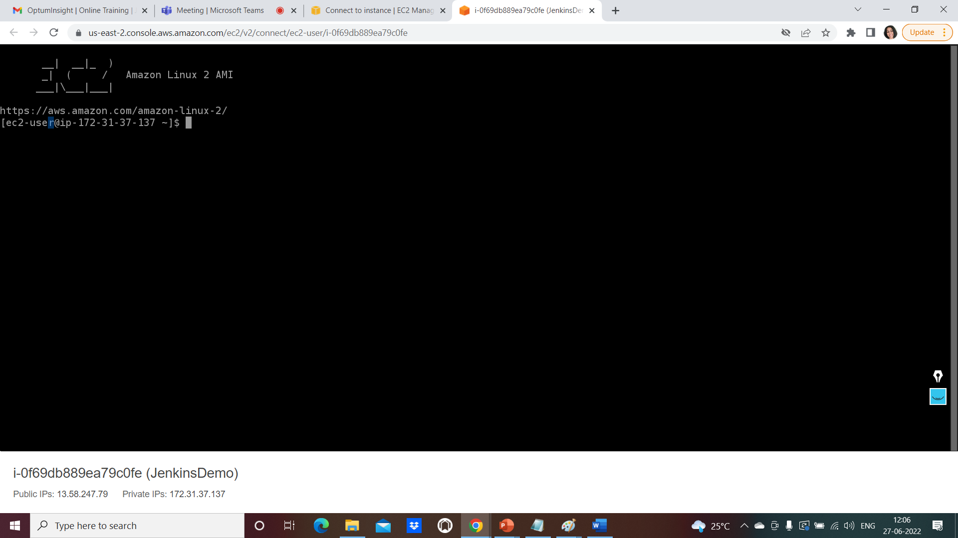

**On the Mac machine**

Open your terminal

cd downloads/

chmod 400 27Jun.pem

SSH command to connect to the aws server form local

ssh -i "27Jun.pem" ec2-user@ec2-13-58-247-79.us-east-2.compute.amazonaws.com

On windows machine:

Open command prompt or git bash

cd downloads/

execute below command

ssh -i "27Jun.pem" [ec2-user@ec2-13-58-247-79.us-east-2.compute.amazonaws.com](mailto:ec2-user@ec2-13-58-247-79.us-east-2.compute.amazonaws.com)

give yes

you will connect to the instance

Once connected to the server, escalate the permission of current user

OR

Become the root user

$ sudo su –